Plane Angle
# Source: AI Source: Provided by: [Data Path: Persons Table -> ID Column: 1, Name_En Column: Motasem Essam] -> From: [ChatGPT] on [7/25/2026]
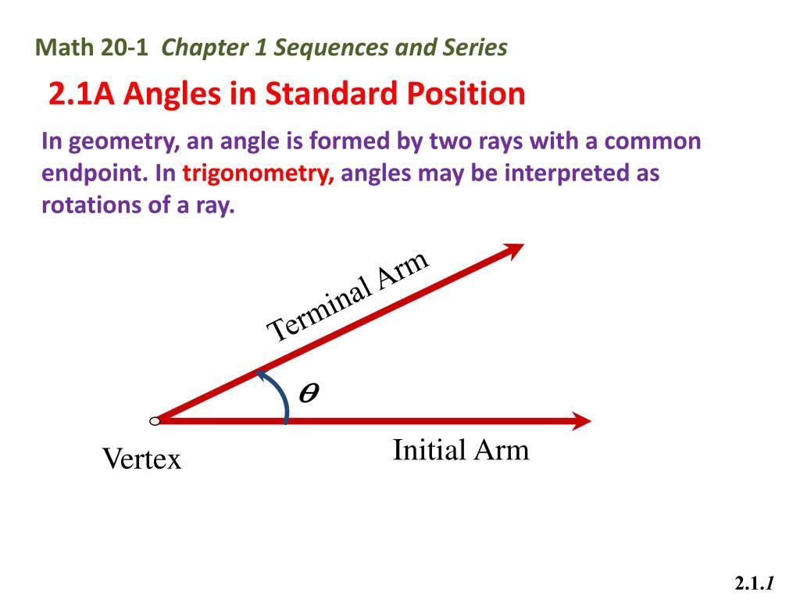
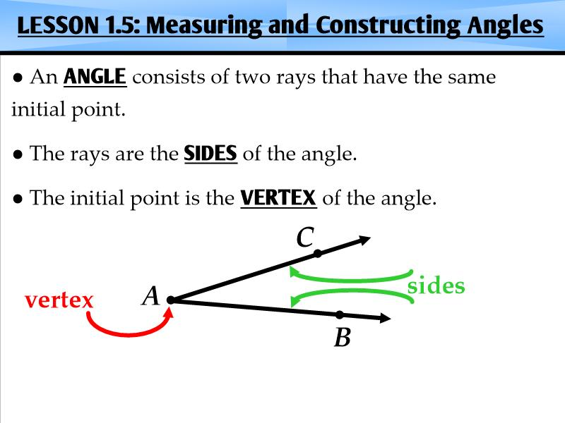
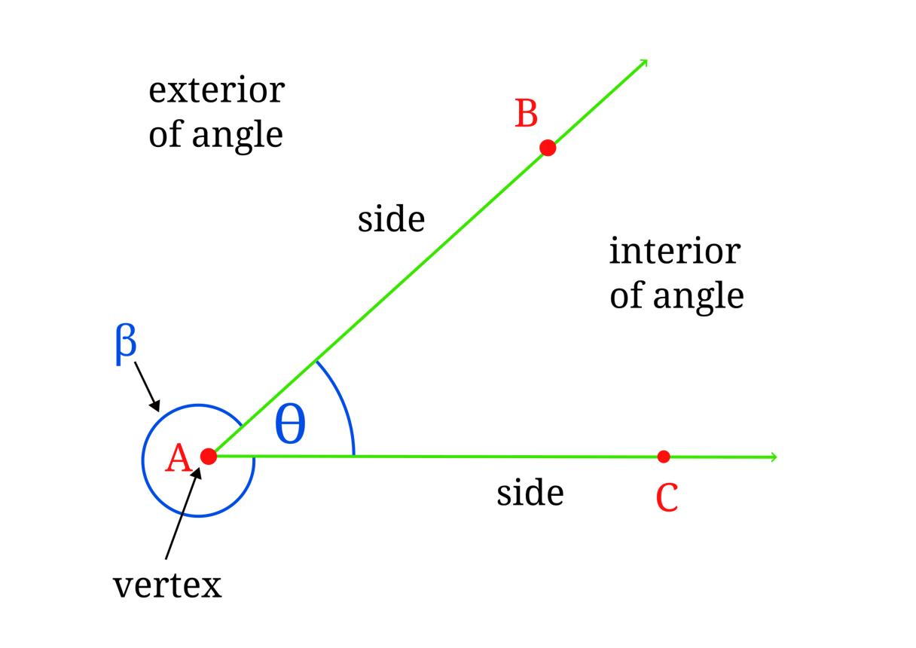

Definition
# Source: AI Source: Provided by: [Data Path: Persons Table -> ID Column: 1, Name_En Column: Motasem Essam] -> From: [ChatGPT] on [7/25/2026]
A plane angle is an angle formed by two rays that share a common endpoint and lie in the same plane.
The common endpoint is called the vertex, and the two rays are called the sides or arms of the angle. The angle measures the amount of rotation or separation between the two rays within that plane.
A plane angle is usually measured in degrees $\left(∘\right)$ or radians.
For example, if rays $\overset{→}{OA}$ and $\overset{→}{OB}$ share the endpoint $O$, they form the plane angle $∠AOB$.
Although plane angles can appear in three-dimensional objects, each individual plane angle is measured within a two-dimensional plane.

Simple definition
# Source: AI Source: Provided by: [Data Path: Persons Table -> ID Column: 1, Name_En Column: Motasem Essam] -> From: [ChatGPT] on [7/25/2026]
A plane angle is the opening between two rays that start at the same point and lie in one flat plane.
For example, the angle between the two hands of a clock is a plane angle because both hands can be considered to lie in the same plane.

Key characteristics
# Source: AI Source: Provided by: [Data Path: Persons Table -> ID Column: 1, Name_En Column: Motasem Essam] -> From: [ChatGPT] on [7/25/2026]
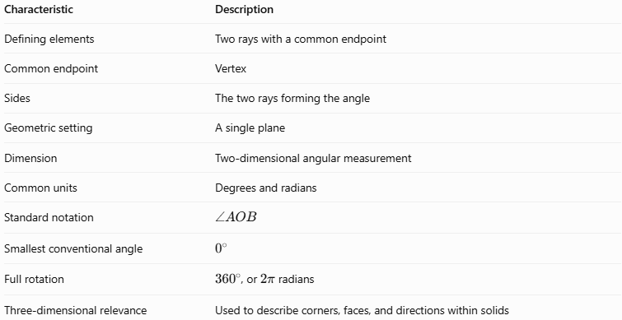
Characteristic | Description
Defining elements | Two rays with a common endpoint
Common endpoint | Vertex
Sides | The two rays forming the angle
Geometric setting | A single plane
Dimension | Two-dimensional angular measurement
Common units | Degrees and radians
Standard notation | $$∠AOB$$
Smallest conventional angle | $$0^{∘}$$
Full rotation | ${360}^{∘}$, or $2π$ radians
Three-dimensional relevance | Used to describe corners, faces, and directions within solids

Geometric representation
# Source: AI Source: Provided by: [Data Path: Persons Table -> ID Column: 1, Name_En Column: Motasem Essam] -> From: [ChatGPT] on [7/25/2026]
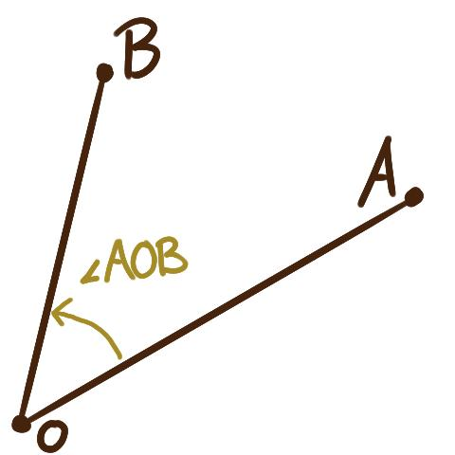
A plane angle is defined by its two arms and their common vertex. The curved arc between the arms indicates which angle is being considered.
The angle $θ$ measures the opening between the two rays.

Types of plane angles by measure
# Source: AI Source: Provided by: [Data Path: Persons Table -> ID Column: 1, Name_En Column: Motasem Essam] -> From: [ChatGPT] on [7/25/2026]
Plane angles can be classified according to their measure.

1. Acute angle
# Source: AI Source: Provided by: [Data Path: Persons Table -> ID Column: 1, Name_En Column: Motasem Essam] -> From: [ChatGPT] on [7/25/2026]
An angle greater than $0^{∘}$ but less than ${90}^{∘}$.
Example: ${45}^{∘}$.
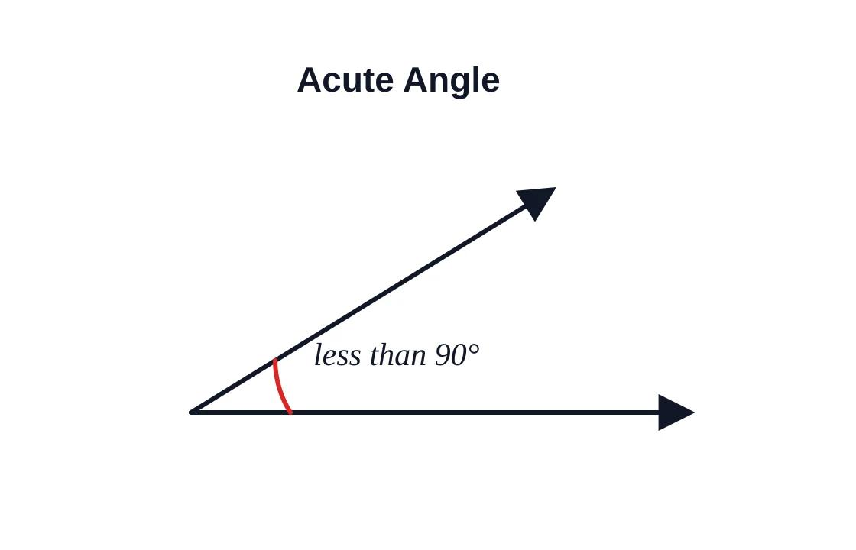

2. Right angle
# Source: AI Source: Provided by: [Data Path: Persons Table -> ID Column: 1, Name_En Column: Motasem Essam] -> From: [ChatGPT] on [7/25/2026]
An angle measuring exactly ${90}^{∘}$.
Example: The corner of a rectangular face of a cube.
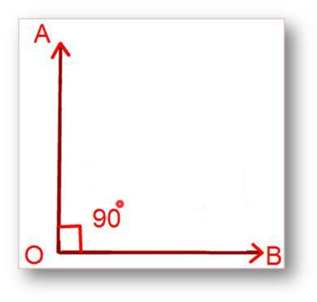

3. Obtuse angle
# Source: AI Source: Provided by: [Data Path: Persons Table -> ID Column: 1, Name_En Column: Motasem Essam] -> From: [ChatGPT] on [7/25/2026]
An angle greater than ${90}^{∘}$ but less than ${180}^{∘}$.
Example: ${120}^{∘}$.
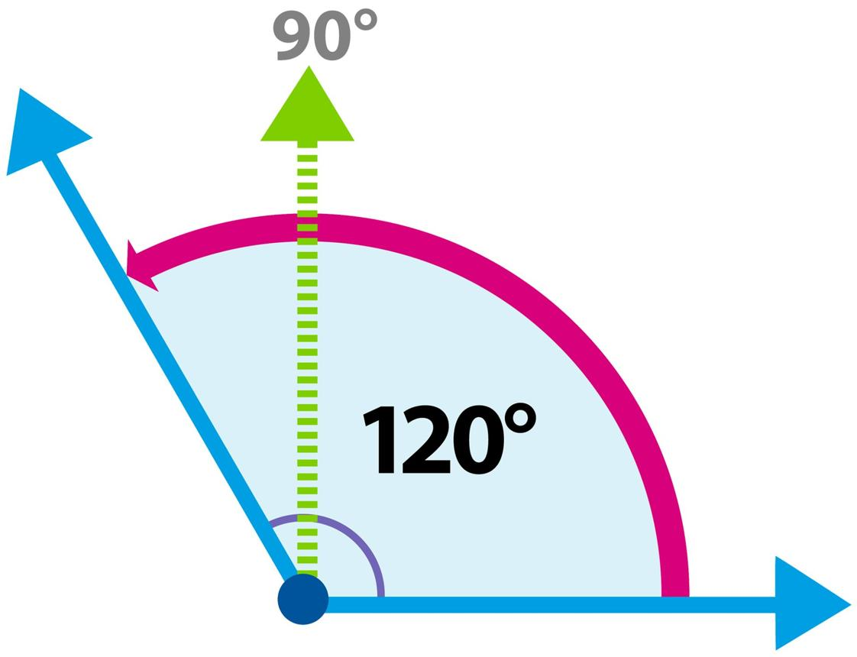

4. Straight angle
# Source: AI Source: Provided by: [Data Path: Persons Table -> ID Column: 1, Name_En Column: Motasem Essam] -> From: [ChatGPT] on [7/25/2026]
An angle measuring exactly ${180}^{∘}$. Its arms point in opposite directions along the same line.
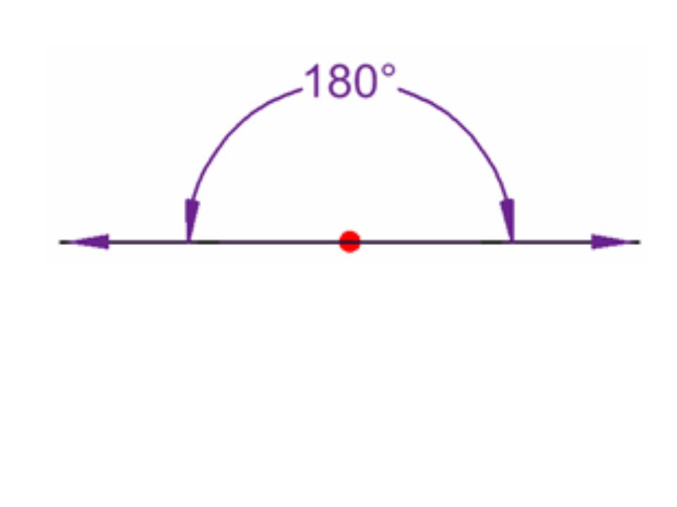

5. Reflex angle
# Source: AI Source: Provided by: [Data Path: Persons Table -> ID Column: 1, Name_En Column: Motasem Essam] -> From: [ChatGPT] on [7/25/2026]
An angle greater than ${180}^{∘}$ but less than ${360}^{∘}$.
Example: ${240}^{∘}$.
A plane angle can also represent a zero angle ($0^{∘}$) when its two rays coincide, or a full angle (${360}^{∘}$) when one ray completes a full rotation and returns to its starting direction.
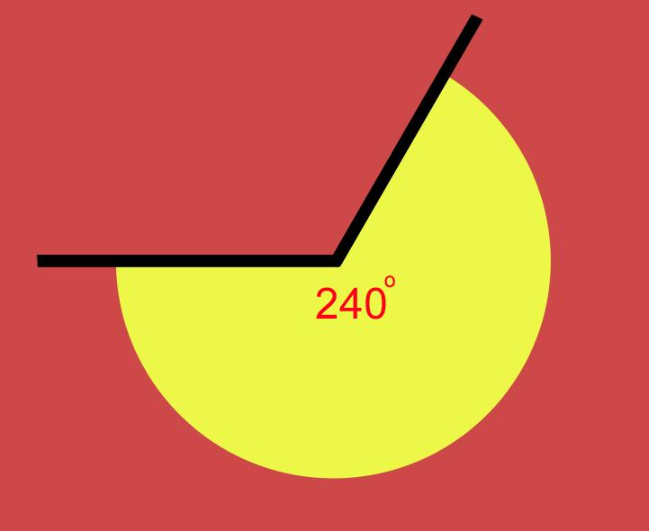

Mathematical representations and formulas

Degree and radian conversion
# Source: AI Source: Provided by: [Data Path: Persons Table -> ID Column: 1, Name_En Column: Motasem Essam] -> From: [ChatGPT] on [7/25/2026]
A full rotation is ${360}^{∘}=2π$ radians. Therefore,
$$\boxed{{180}^{∘}=π\text{ radians}}$$
To convert degrees to radians:
$$\boxed{θ_{rad}=θ_{deg}\frac{π}{180}}$$
To convert radians to degrees:
$$\boxed{θ_{deg}=θ_{rad}\frac{180}{π}}$$
Example: Convert ${60}^{∘}$ into radians.
$${60}^{∘}×\frac{π}{{180}^{∘}}=\boxed{\frac{π}{3}\text{ radians}}$$

Calculating the angle using vectors
# Source: AI Source: Provided by: [Data Path: Persons Table -> ID Column: 1, Name_En Column: Motasem Essam] -> From: [ChatGPT] on [7/25/2026]
In three-dimensional coordinates, two rays can be represented by their direction vectors $u$ and $v$.
The angle between them is given by
$$\boxed{θ=\cos^{-1}\left(\frac{u⋅v}{\left\|u\right\|\left\|v\right\|}\right)}$$
where:
- $u⋅v$ is the dot product.
- $\left\|u\right\|$ and $\left\|v\right\|$ are the magnitudes of the vectors.
- $θ$ is the smaller angle between the two direction vectors, from $0^{∘}$ to ${180}^{∘}$.
This formula works for rays that lie in a plane, including planes positioned anywhere in three-dimensional space.

Worked examples
# Source: AI Source: Provided by: [Data Path: Persons Table -> ID Column: 1, Name_En Column: Motasem Essam] -> From: [ChatGPT] on [7/25/2026]
Example 1: Identifying a plane angle in a solid
Problem: Two edges of a cube meet at vertex $O$. What type of angle do they form if the edges are perpendicular?
Solution:
Adjacent edges of a cube meet at right angles. Therefore,
$$\boxed{∠AOB={90}^{∘}}$$
The angle is a right plane angle because both edges lie in the same face plane of the cube.
Example 2: Calculating an angle using vectors
Problem: Find the angle between the direction vectors
$$u=\left(1,0,0\right), v=\left(1,1,0\right).$$
Step 1: Calculate the dot product.
$$u⋅v=1\left(1\right)+0\left(1\right)+0\left(0\right)=1$$
Step 2: Calculate the magnitudes.
$$\left\|u\right\|=1, \left\|v\right\|=\sqrt{2}$$
Step 3: Apply the angle formula.
$$\cos{θ}=\frac{1}{\sqrt{2}}$$
Therefore,
$$\boxed{θ={45}^{∘}}$$
The vectors form an acute plane angle.
Example 3: Finding a missing angle
Problem: Two adjacent plane angles form a straight angle. One measures ${65}^{∘}$. Find the other.
Solution:
Angles forming a straight angle add up to ${180}^{∘}$.
$$θ+{65}^{∘}={180}^{∘}$$
$$θ={180}^{∘}-{65}^{∘}$$
$$\boxed{θ={115}^{∘}}$$
The missing angle is obtuse.

Plane angle compared with other angles in solid geometry
# Source: AI Source: Provided by: [Data Path: Persons Table -> ID Column: 1, Name_En Column: Motasem Essam] -> From: [ChatGPT] on [7/25/2026]
The term plane angle is particularly important because solid geometry includes other types of angles that describe relationships between planes or regions of space.
1. Plane angle
Formed by two rays sharing a vertex in one plane. It measures the opening between the rays.
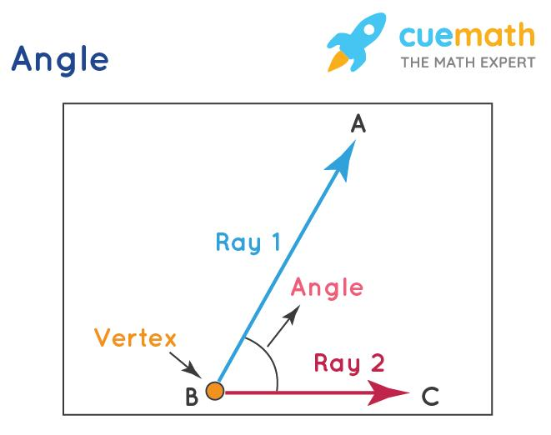
2. Dihedral angle
Formed by two planes that meet along a common line. It measures the opening between the planes.
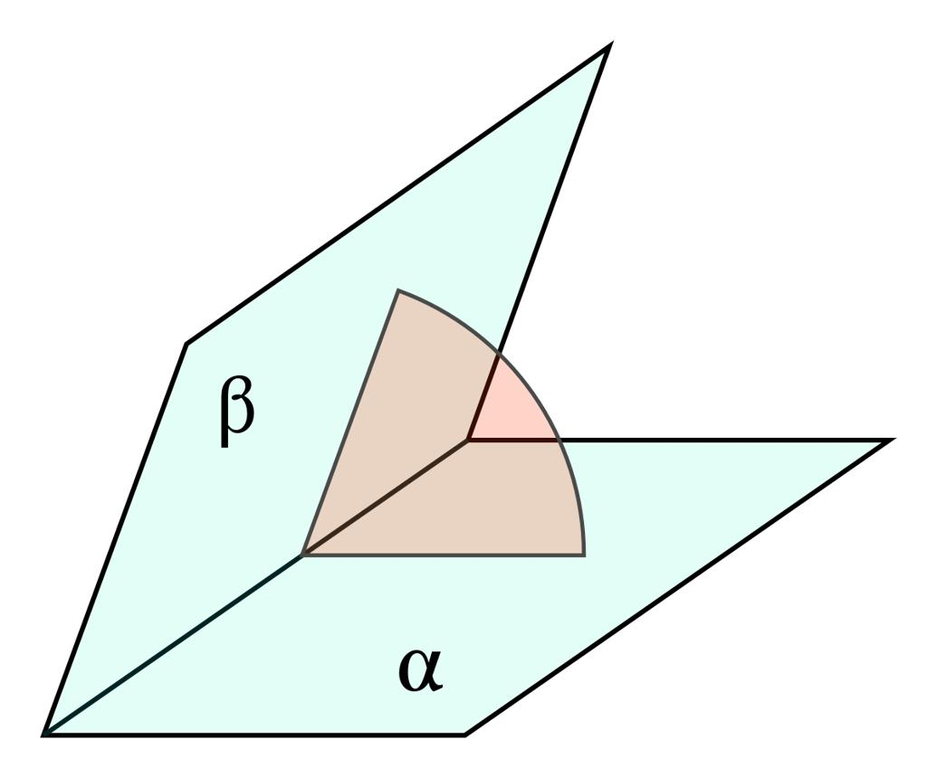
3. Solid angle
Describes how much of three-dimensional space a region subtends at a point, such as the space enclosed by a cone.
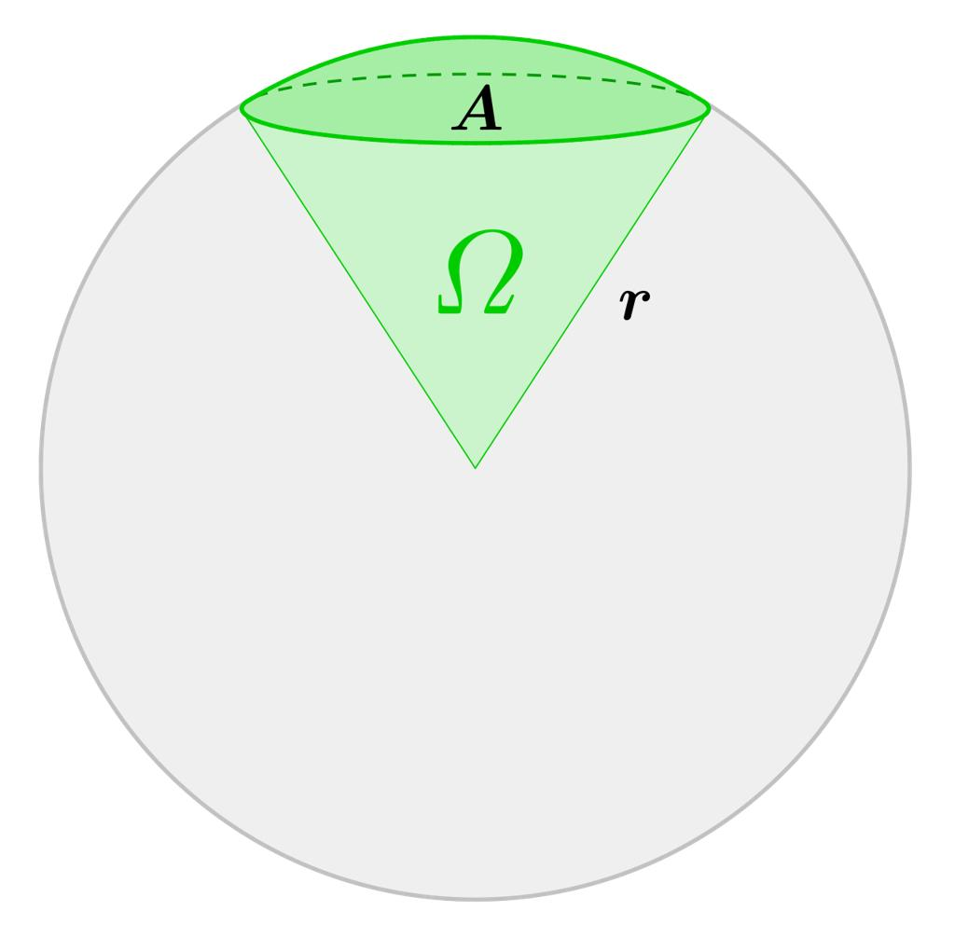
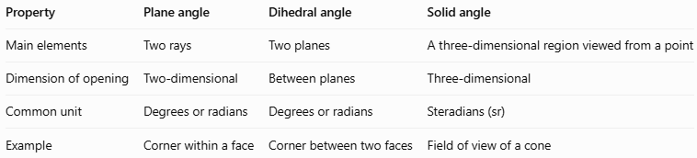
Property | Plane angle | Dihedral angle | Solid angle
Main elements | Two rays | Two planes | A three-dimensional region viewed from a point
Dimension of opening | Two-dimensional | Between planes | Three-dimensional
Common unit | Degrees or radians | Degrees or radians | Steradians (sr)
Example | Corner within a face | Corner between two faces | Field of view of a cone
Important distinction: A plane angle can be used to measure a dihedral angle by taking a cross-section perpendicular to the planes' common edge. The resulting plane angle represents the dihedral angle's measure.

Applications
# Source: AI Source: Provided by: [Data Path: Persons Table -> ID Column: 1, Name_En Column: Motasem Essam] -> From: [ChatGPT] on [7/25/2026]
- Polyhedra: Measuring angles between edges on the same face of cubes, prisms, and pyramids.
- Architecture: Describing angles within flat faces and two-dimensional construction plans.
- Engineering: Measuring the angle between directions or components that lie in a common plane.
- Trigonometry: Applying sine, cosine, and tangent to calculate lengths and angles.
- Computer graphics: Calculating the angle between vectors in a three-dimensional scene.
- Physics: Describing directions of motion, forces, and other vector quantities.

Key points
# Source: AI Source: Provided by: [Data Path: Persons Table -> ID Column: 1, Name_En Column: Motasem Essam] -> From: [ChatGPT] on [7/25/2026]
- A plane angle is formed by two rays sharing a common endpoint in the same plane.
- The common endpoint is the vertex.
- Plane angles can be measured in degrees or radians.
- An acute angle is less than ${90}^{∘}$, a right angle equals ${90}^{∘}$, and an obtuse angle is between ${90}^{∘}$ and ${180}^{∘}$.
- A straight angle measures ${180}^{∘}$, while a reflex angle is between ${180}^{∘}$ and ${360}^{∘}$.
- The angle between two nonzero vectors can be calculated using the dot-product formula.
- Plane angles differ from dihedral angles and solid angles, which describe different geometric relationships.

Conclusion
# Source: AI Source: Provided by: [Data Path: Persons Table -> ID Column: 1, Name_En Column: Motasem Essam] -> From: [ChatGPT] on [7/25/2026]
A plane angle is a fundamental geometric concept used throughout plane and solid geometry. It measures the opening between two rays that share a vertex and lie in a common plane. In solid geometry, plane angles help describe the corners of faces, relationships between edges, and angles derived from three-dimensional structures.

